Methocel Delivery System

Adriaan Riet

Sean Lawry

Austin Smith

October 7, 2014

Table of Contents

Abstract 3

Introduction 3

Apparatus Design 3

Experimental Procedure 5

Safety 5

Theory and Data 5

Results 7

Analysis of Results 7

Sources of Error 8

Conclusions & Recommendations 8

Appendix A 8

Sources 8

## Abstract

Methocel is to be pumped from a railway terminal to a nearby plant. A delivery system is already in place, but must be adequate to transport the non-Newtonian fluid without exceeding the rupture disk pressure rating (250 psig). An apparatus has been constructed to study the rheology of methocel. The apparatus measures flow rate and pressure drop as a function of distance. This rheological data was used to determine the adequacy of the transport system. The team predicted a pressure drop of 81 psi, which is well below the 250 psig pressure rating.

## Introduction

Methocel must be transported to a new plant from the nearby railway terminal. A delivery system is already in place, and it is the team’s objective to determine if it can transport 75 gallons per minute of a 1% (by weight) methocel solution without exceeding the rupture disk pressure rating (250 psig). The company lab contains a system designed to measure flow rate and pressure drop of the methocel solution in two different pipe sizes. Methocel is a known non-Newtonian fluid and cannot be modeled like most liquids. DOW Chemical lists methocel as a pseudo-plastic fluid that follows the power law model. This model and the data from the apparatus can be been used to determine the rheological parameters n and K (discussed below) of methocel, as well as the pressure drop in the pipe. The pressure drop through the pipe represents the minimum required pressure at the existing transport system. If the the minimum pressure exceeds the rupture disk rating, a new transport system will be designed. The team was also assigned to compare the behavior of methocel solution vs. water.

## Apparatus Design

A large tank with two mixers keeps the 1% methocel solution well-mixed. A computer-controlled valve maintains a constant flow rate. A second valve switches between the two pipe sizes. Each of these copper pipes has a pressure transducer that measures pressure drop as a function of distance. The pressure drop and flow rate data is then transmitted to a computer. The computer is set to provide one measurement per second for 100 seconds. A detailed diagram of the apparatus can be seen in Figure 1.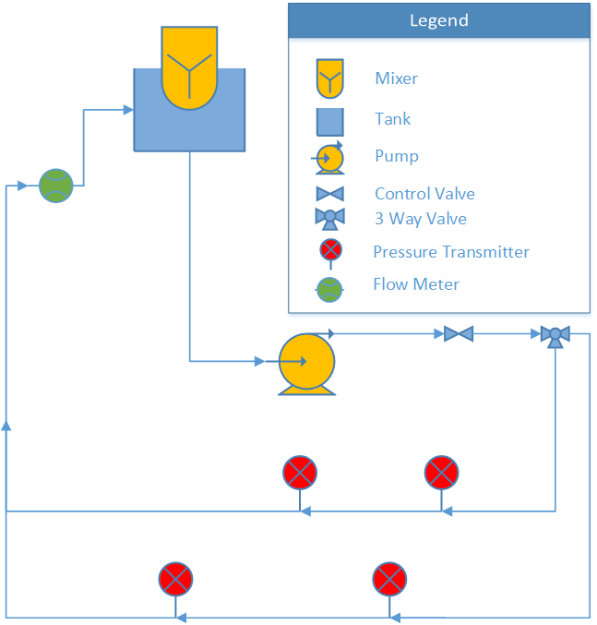

*Figure 1:* Schematic of the Apparatus

## Experimental Procedure

The experiment was performed in two different pipes of different diameters, at ten different flow rates in each pipe. Performing the experiment in two separate pipe sizes allows for two separate experiments, which can be compared to determine the validity of the data. Each flow rate contains 100 measurements, each taken in one-second intervals. A randomization table was created to minimize systematic disturbances. Measured variables included the pressure drop across the active pipe, flow rate, time the reading was taken, pressure drop across the inactive pipe, ambient temperature, ambient pressure, flow setpoint and the valve controller output.

## Safety

There were important safety measures related to this experiment. First, only the mixers were turned on to mix the solution. Then the pump was turned on to collect the data. The pump was turned off as soon as the data collection was completed. One of the team members was always observing the tank while the system was running. This was to ensure others would not come into contact with any of the equipment. The valve that changed the flow from the large to small diameter pipe had to be switched only when the pump was off. Because fluids were involved in this experiment, care was taken to minimize any potential electrical hazard. Methocel in solution is not particularly hazardous, but is flammable as a powder. The flammability hazard was low since the experimental material was methocel in solution.

## Theory and Data

It is assumed that methocel is a power law fluid. The power law is of the form:

|  |  |  |
| --- | --- | --- |
|  | $τ={K(-\frac{dv}{dr})}^{n}$ | (1) |

where $τ$ is shear stress, $K$ and $n$ are empirically determined constants, and $\frac{dv}{dr}$ is a change in velocity per change in radial distance. $τ$ is calculated by the equation

|  |  |  |
| --- | --- | --- |
|  | $$τ= -\frac{R}{2}\frac{dP}{dx}$$ | (2) |

which requires the pressure drop (*R*) and pipe radius, both of which are specified. In order to determine $n$ and $K$, the relation

|  |  |  |
| --- | --- | --- |
|  | $$\ln{(τ})=n\ln{(v})+\{\ln{(K})+n\ln{(\frac{2(3n+1)}{nD}})\}$$ | (3) |

was used. By fitting shear stress and velocity to a line, $n$ and $K$ was determined. The equation for friction loss due to flow through a circular pipe is

|  |  |  |
| --- | --- | --- |
|  | $$ΔP=\frac{-fLv^{2}}{2D}$$ | (4) |

where P is pressure, f is the Darcy friction factor, L is the length of the pipe, v is average velocity through the pipe, and D is the inner diameter of the pipe.

$f$ was found using a modified Reynolds number, given by

|  |  |  |
| --- | --- | --- |
|  | $$Re=\frac{8ρv^{2}}{K}(\frac{nD}{2(3n+1)v})^{n}$$ | (5) |

and using a Non-Newtonian Moody chart.

In a system using water, the Reynolds number and friction factor would be given by equation 6.

|  |  |  |
| --- | --- | --- |
|  | $$Re=\frac{ρvD}{μ},$$ | (6) |

|  |  |  |
| --- | --- | --- |
|  | (turbulent). | (7) |

Once $f$ was acquired, an estimate of the pressure drop was obtained with the above relations.

## Results

The current pipeline in place is suitable to transport methocel from the railway to the plant. The pressure drop calculated through experimentation is 81.4 psig and this is less than the maximum pressure of 250 psg. The pressure drop of water running through the same piping system was calculated at 26 psig.  The flow behavior index (n) determines the type of fluid. Newtonian fluids are n=1, pseudo-plastic fluids n<1, and bingham plastics n>1. The fluids act differently under shear stress. Pseudo-plastic fluids get thinner under more shear stress, bingham plastics get thicker under a higher shear stress. The calculated flow behavior index of 1% methocel was determined to be 0.64. The results show conclusively that methocel is a pseudo-plastic fluid.

|  |  |  |  |  |  |  |
| --- | --- | --- | --- | --- | --- | --- |
|  | n | K | Re | f | dP (Pascals) | dP (psi) |
| small pipe | 0.59 | 1.21 | 950 | 0.07 | 5.61E+05 | 81.3 |
| large pipe | 0.70 | 0.69 | 896 | 0.07 | 5.94E+05 | 86.2 |
| weighted average | 0.64 | 0.89 | 949 | 0.07 | 5.61E+05 | 81.4 |

## Analysis of Results

The measurements were taken in a random order to ensure any disturbances had a minimal impact on the data. The fluid property also has thinning properties under shear stress, which will bring any error under the measured pressure drop value. This helps keep the measurement within specifications.

## Sources of Error

The data taken showed high levels of confidence in the measured results. The experiment however did have some sources of error. The main sources of error come from the measurement devices used. One pressure transducer was measuring a slight pressure drop even without flow. Also the smaller pipe was slightly bowed, due to a table being pushed up against it. The flow rate being controlled by the valve also was not perfectly constant. This could add some error to the calculations. There are also possible errors due to the pipes having a different roughness. These each should be small, but contribute to the error that was seen in the results.

## Conclusions & Recommendations

The pipeline in place can transport methocel to the plant. The pressure drop of methocel in the current piping system is 81.4 psig, while the system can maintain up to 250psig. The data had a high level of confidence as shown in figure x. Methocel had a measured n value of 0.64 which determines that it is a pseudo-plastic fluid. Methocel is expected to run through the pipe with about three times the pressure drop as water would. This easily reaches the specifications of the existing pipeline and no new pipeline system is necessary.

## Appendix A

|  |  |
| --- | --- |
| D |  |
| f |  |
| K |  |
| L |  |
| N |  |
| P |  |
| R |  |
| ρ |  |
| Re |  |
|  |  |
|  |  |

## Sources